

NAME:______________

ROLL NO:______________

ASSIGNMENT NO:______________

SUBMISSION DATE:________________

NON-Verbal Communication

- The non-verbal is the type of communication.In which we communicate with other in forum of body gesture without using any word.

- During communication we use 35% of our verbal communication and 65% of our non-verbal communication this show that non-verbal has much importance in communication.

- It not only defines your image or personality but also describes your feelings and emotions which are unable express in words.

- Communication is most important Element between speaker and listener.

- If your are good at non-verbal and verbal communication its mean you are good communicator.
Types of Non-Verbal Communication

- Eye contact
- Facial Expression
- Posture
- Touch
- Gesture

Eye Contact:

- Eye contact is important type of non-verbal communication. During talking to someone and maintaining the eye contact shows that you are confident and you are interseted in particular topic.

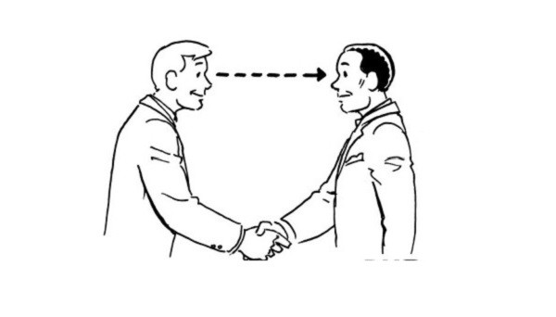

Facial Expression:

- Facial Expression is also important type of communication. During communication facial expression shows that wither your are happy or sad,anger,fear.

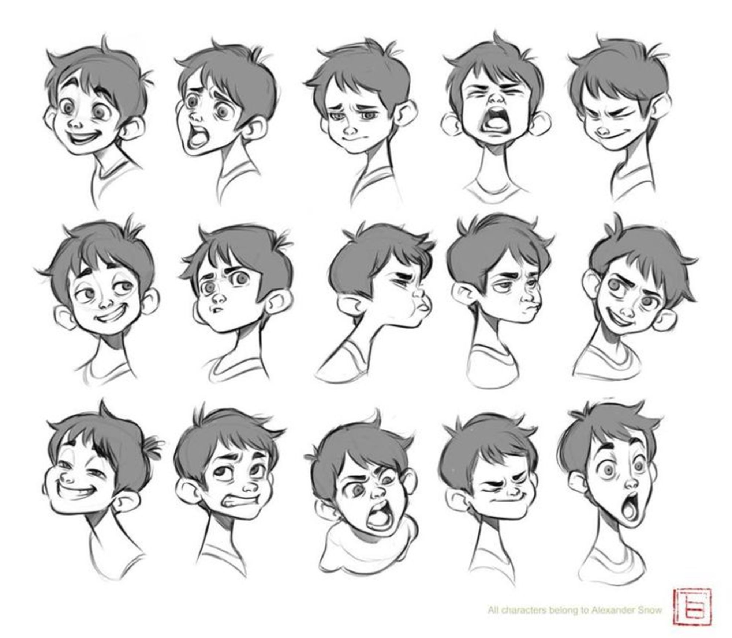
Posture:

- It is also type of non-verbal communication. Posture describe how you carry yourself around people and it talk a lot about you. How you sit,stand,move it not only indicates your mood but also personality.
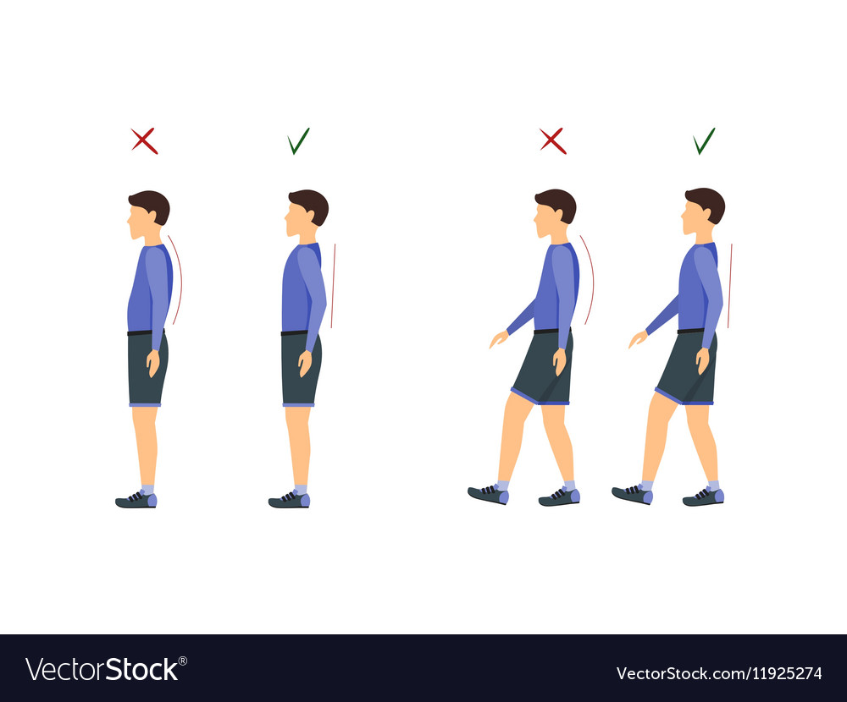
Touch:

- It is the type of non-verbal communication.When you come to physical you give a body gesture like shaking hand.


Gesture:

- It is also the type of non-verbal communication. Using of your hand,face or body movements.

